*Courier Service Management*

### Group Members :

### Mr.Harshvardhan Koruche (PRN: 230344220097)

### Mr.Pruthviraj Desai (PRN: 230344220044)

### Mr.Onkar Kalekar (PRN :230344220090)

### Mrs.Shivanjali Bhosale (PRN : 230344220194)

### Mr.Shreejay Mane (PRN : 230344220197)

### 1



**2**

**Table of Contents**

1. Scope of Project4

2. End user roles5

3. Objectives6

4. Project Limitations7

5. Roles and Functionalities……………………………………………………………………………...8

6. Use Case Diagram……………………………………………………………………………………..9

7. Entity relation Diagram………………………………………………………………………………..10

8. UI Design……………………………………………………………………………………………...11

**3**

1.Scope of Project:

The courier service management system is aimed at managing the process of sending and receiving couriers. The system will provide a platform for the end-users to book their couriers online and track the delivery status. The project will be implemented using web-based technologies, which can be accessed from anywhere with an internet connection.

A courier management system (CMS) is a software application that automates and streamlines the process of managing and tracking shipments, from the time of pick-up to delivery. The system typically includes a variety of features and functionalities to help businesses efficiently manage their courier operations, improve customer service, and increase operational efficiency.

Here are some of the key features and functionalities of a typical courier management system:

1. Order management: The system enables businesses to receive and manage orders from multiple channels, including online, phone, email, and in-person.
2. Shipment tracking: The system allows businesses and customers to track the progress of their shipments in real-time, from pick-up to delivery.
3. Dispatch management: The system optimizes the dispatch process by automatically assigning couriers based on proximity, workload, and other factors.
4. Route optimization: The system helps couriers optimize their routes to reduce travel time and fuel costs, while ensuring timely delivery.
5. Fleet management: The system allows businesses to manage their fleet of vehicles, including maintenance schedules, fuel usage, and driver performance.
6. Inventory management: The system tracks inventory levels and provides alerts when stock levels fall below a certain threshold.
7. Reporting and analytics: The system generates reports and provides analytics to help businesses identify areas for improvement and make data-driven decisions.
8. Customer service: The system provides tools for businesses to communicate with customers, including automated notifications, alerts, and feedback mechanisms.

In summary, a courier management system offers a wide range of functionalities and benefits that can help businesses improve their courier operations and provide a better customer experience.

4

2.End User Roles:

A courier service management system typically involves different types of end users who play specific roles in the system. Here are some of the typical end user roles in a courier service management system:

1. Customers: These are the end users who use the courier service to send or receive packages. Customers can create orders, track their shipments, and communicate with the courier service through the system.
2. Dispatchers: Dispatchers are responsible for assigning courier personnel to specific routes and orders. They use the system to manage orders, assign drivers, and monitor the status of shipments.
3. Couriers: Couriers are the personnel who physically pick up and deliver the packages. They use the system to receive assignments, track their routes, and communicate with dispatchers and customers.
4. Administrators: Administrators are the personnel responsible for managing the courier service management system. They use the system to set up user accounts, manage orders, monitor system performance, and perform other administrative tasks.

Each end user role in the courier service management system has different levels of access to the system's functionalities and data, based on their specific needs and responsibilities. For example, customers may only have access to view their orders and track their shipments, while dispatchers may have access to more advanced features like route optimization and order assignment.

Overall, the different end user roles in a courier service management system work together to ensure that packages are delivered quickly, efficiently, and accurately, while providing a high level of customer service.

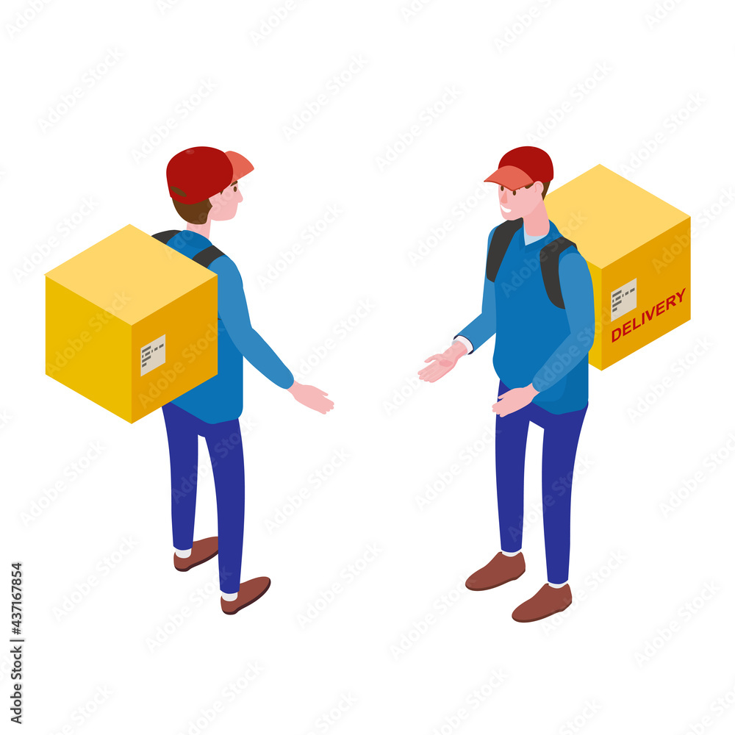

**5**

3.Objectives:

The objectives of a courier service management project are to improve the overall efficiency, accuracy, and quality of the courier service. The following are some specific objectives that a courier service management project may aim to achieve:

1. Improve operational efficiency: The project may aim to automate and streamline various courier service management tasks, such as order processing, dispatching, and tracking, to reduce errors and save time.
2. Enhance customer experience: The project may aim to provide customers with more transparency and better communication throughout the shipment process, including real-time tracking updates and notifications.
3. Optimize resource utilization: The project may aim to improve the utilization of courier personnel, vehicles, and other resources by optimizing routes, minimizing travel times, and reducing fuel costs.
4. Increase productivity: The project may aim to enhance the productivity of courier personnel by providing them with tools and resources to perform their jobs more efficiently and effectively.
5. Ensure accuracy: The project may aim to improve the accuracy of the courier service by implementing barcode scanning, labeling, and other technologies to ensure that packages are delivered to the correct recipient.
6. Ensure compliance: The project may aim to ensure that the courier service is compliant with various industry regulations and standards, such as data privacy and security requirements.

Overall, the objectives of a courier service management project are to improve the quality and efficiency of the courier service, reduce costs, and enhance the customer experience. By achieving these objectives, the courier service can become more competitive, gain market share, and achieve long-term success.

**6**

4.Project Limitations:

While courier service management systems offer many benefits and can improve the efficiency and accuracy of courier operations, there are also some limitations to consider. Here are a few examples:

1. Technological constraints: Courier service management systems rely on technology to function properly. This means that they are subject to technological limitations such as hardware failures, software bugs, and network outages, which can cause delays or disruptions in service.
2. Human error: Despite the automation and optimization provided by courier service management systems, there is still a risk of human error. Couriers may make mistakes when picking up or delivering packages, and dispatchers may assign the wrong orders to the wrong couriers, which can result in delays or lost packages.
3. Security concerns: Courier service management systems often contain sensitive customer and business data. This data can be vulnerable to security breaches, such as hacking or data theft, which can have serious consequences for both the courier service and its customers.
4. Dependency on third-party services: Courier service management systems may depend on third-party services such as GPS tracking, weather data, and payment processing. If these services experience downtime or other issues, it can affect the performance and reliability of the courier service management system.
5. Cost: Implementing and maintaining a courier service management system can be costly, particularly for small businesses with limited resources. The cost of hardware, software, and personnel can be significant, and ongoing maintenance and upgrades may also be required.

It's important to keep these limitations in mind when considering a courier service management system, and to develop strategies to mitigate their impact. By doing so, businesses can ensure that they are making informed decisions about the technology they use and are delivering high-quality courier services to their customers.

**7**

5.Roles and Functionalities:

Different roles in courier service management have different functionalities and responsibilities within the system. Here are some of the key functionalities of each role:

1. Customers: Customers can create and manage orders, track their shipments in real-time, receive notifications and alerts about their packages, and communicate with the courier service through the system. They may also be able to access features such as rate quotes, address verification, and package customization.
2. Dispatchers: Dispatchers are responsible for managing orders, assigning couriers to specific routes and shipments, and monitoring the status of packages throughout the delivery process. They may also be responsible for handling customer inquiries and resolving issues that arise during delivery.
3. Couriers: Couriers use the courier service management system to receive and manage assigned shipments, track their routes, and communicate with dispatchers and customers. They may also be responsible for collecting signatures and other delivery information, as well as updating package status in the system.
4. Administrators: Administrators are responsible for managing the overall operation of the courier service management system. They may be responsible for setting up user accounts, managing orders and shipments, monitoring system performance, and performing other administrative tasks as needed.

Each role has different levels of access and functionality within the courier service management system, based on their specific responsibilities and needs. For example, customers may have access to self-service features such as creating and managing orders, while dispatchers may have access to more advanced features such as route optimization and delivery scheduling.

Overall, the functionalities of different roles in courier service management work together to ensure that packages are delivered efficiently and accurately, while providing a high level of customer service. By optimizing these functionalities and ensuring that they are aligned with the needs of the business and its customers, courier service management systems can help businesses deliver high-quality courier services that meet the demands of a rapidly changing marketplace.

**8**

6.Use Case Diagram:

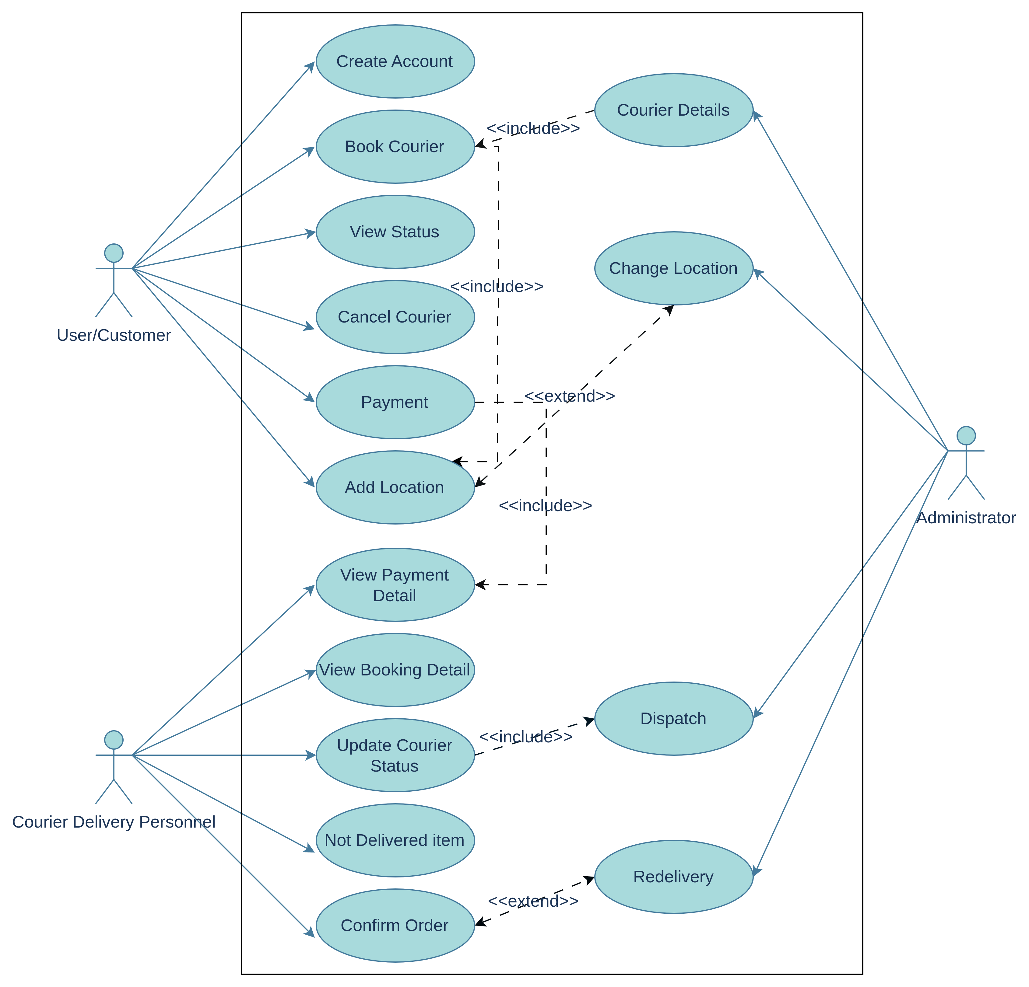

**9**

7.Entity Relation Diagram:

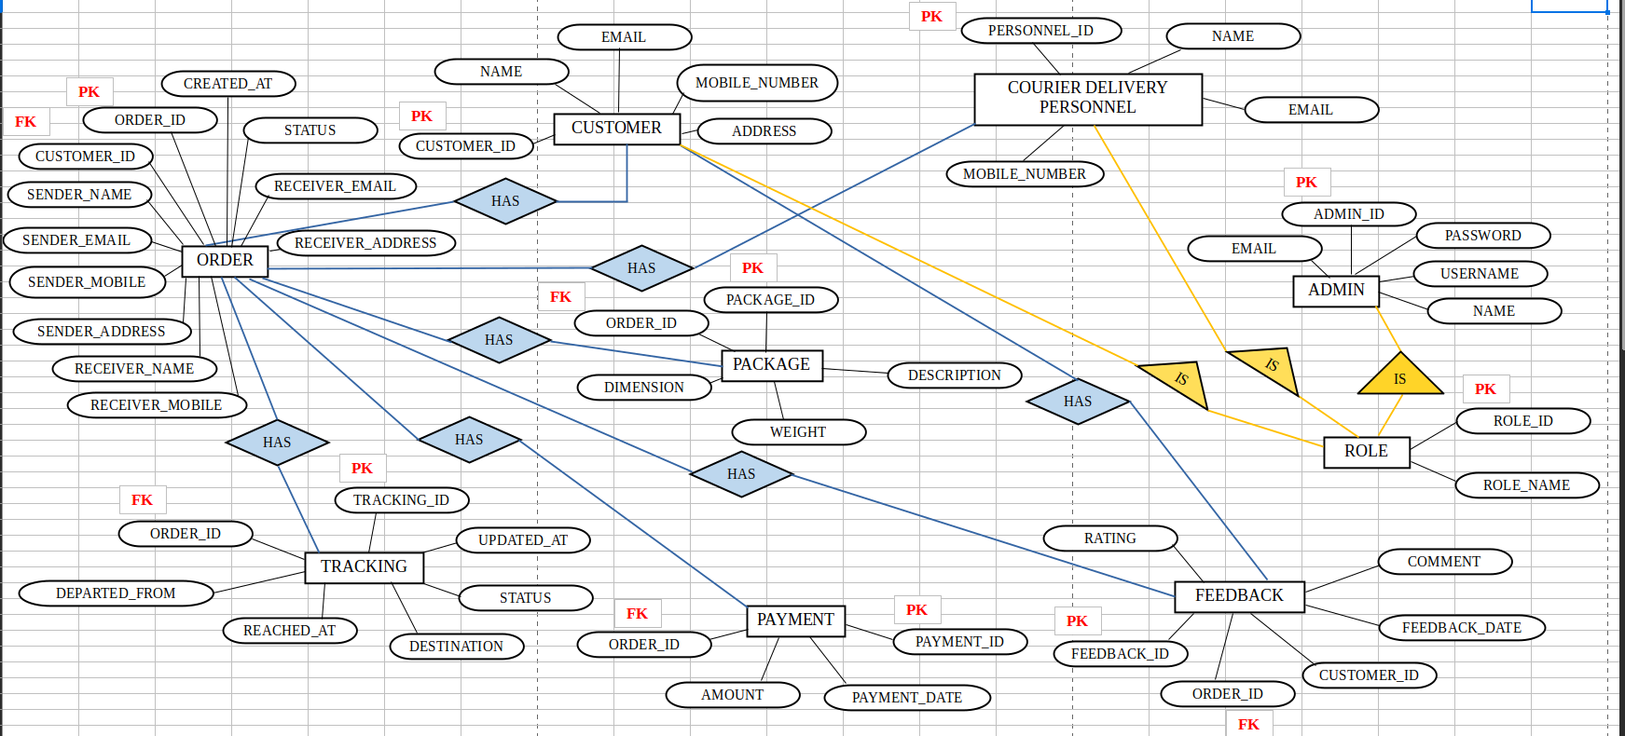

**10**

7.UI Design Diagram:

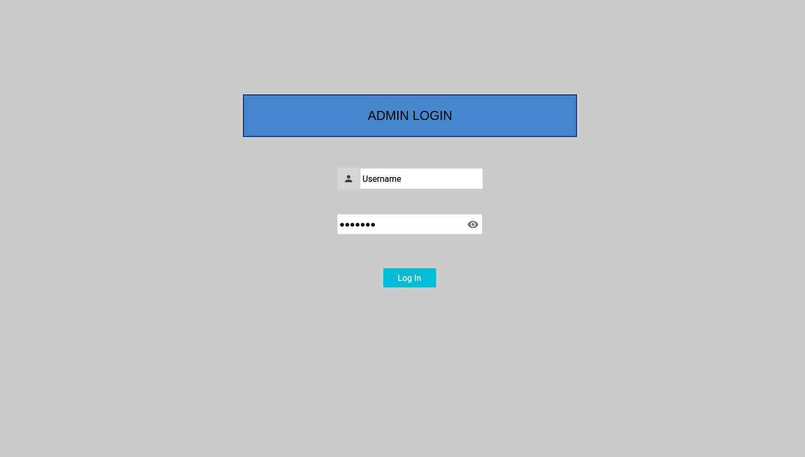**Admin Login**



**Track Courier**

**11**

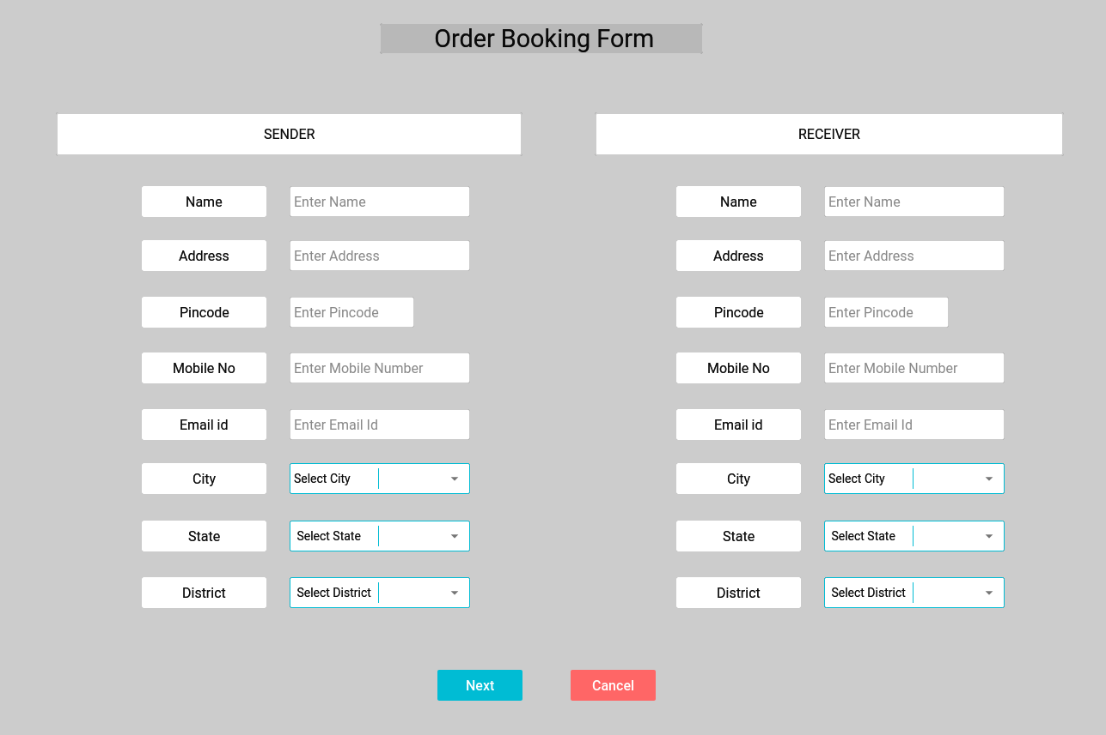

**Order Booking Form**

**12**

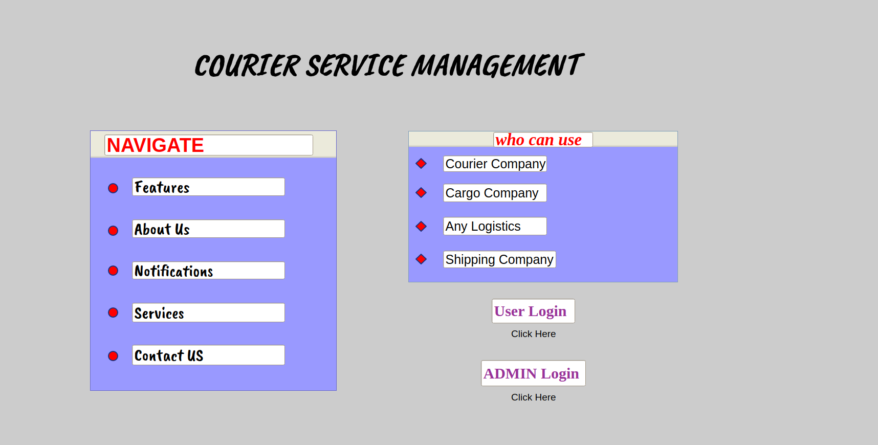

**Home page**

**13**

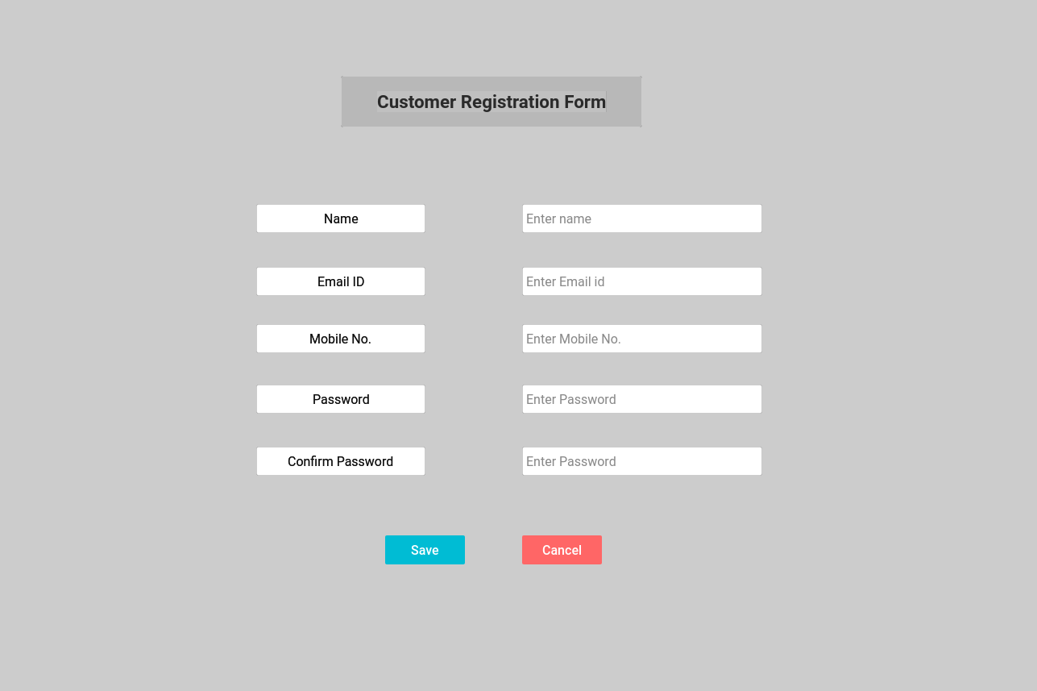

**Customer Registration Form**

**14**

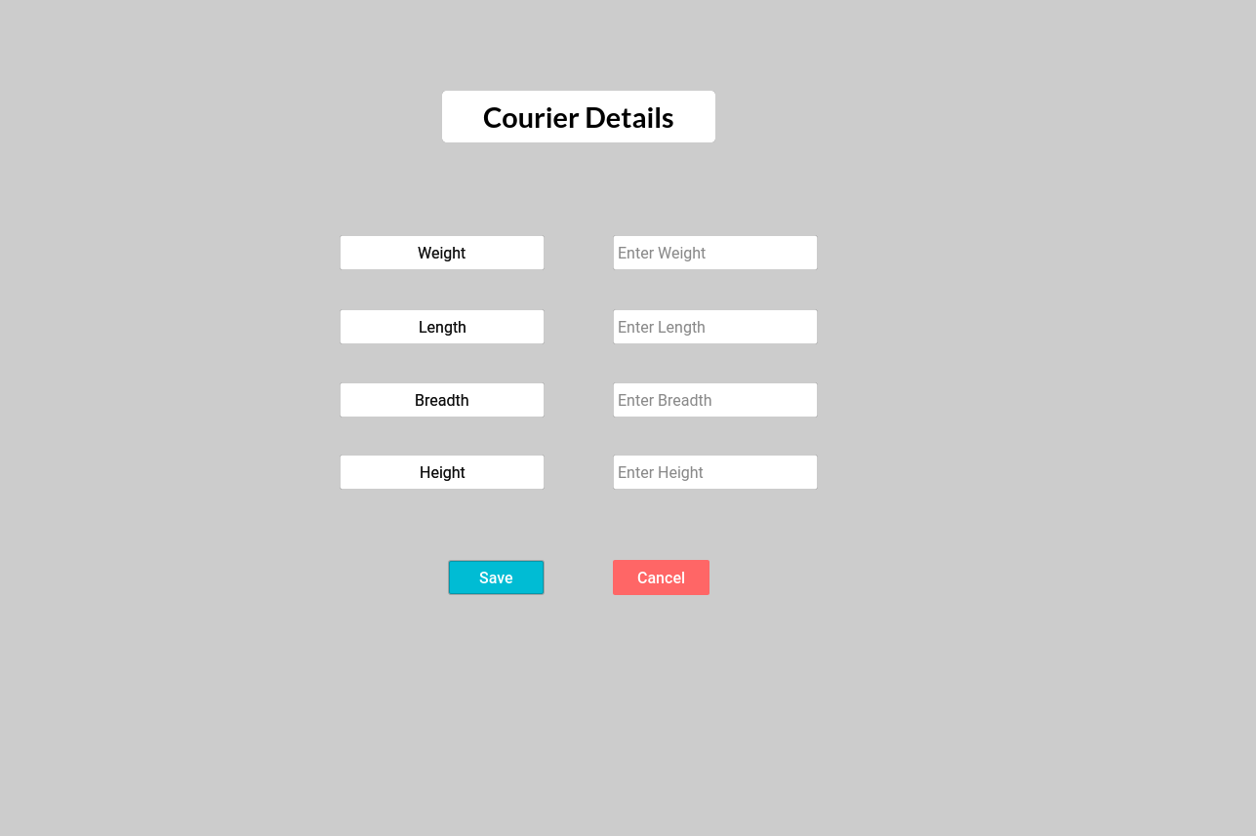

**Courier Details**

**15**